**Working Precedure:**

1. User will see 2 option first.

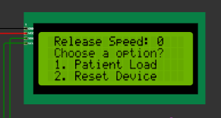

* 1. If option-1 choosed, Selline will released to patient
  2. Before releasing, release speed will be checked. Speed 1- 100 is allowed. If speed out of this range. Below message will show.

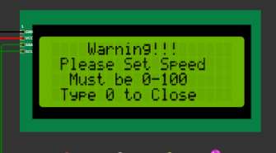

Then the system will return to step 1.

* 1. Otherwise Selline will release with sated speed.

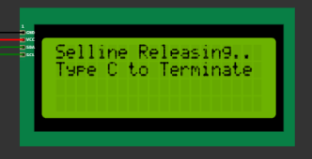

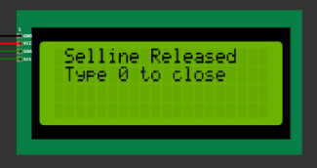

Then system will return to stap 1.

1. If user choose option-2 (Reset Device).

a.

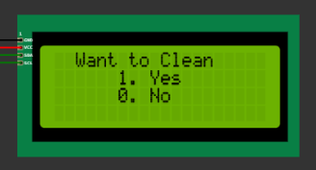

If 1 bottle will clean.

b. Then it will go next,

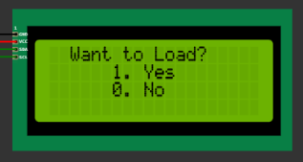

If 1 bottle will load by selline.

c. Then it will go next,

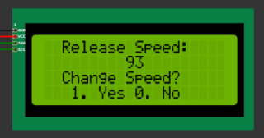

If 1, user will be able to set Selline release speed.

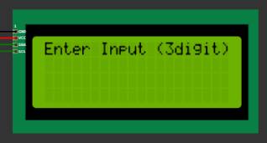

Input will be 3 digit and in range(1-100)

Then system will go to step 1. Thereby user can use all of the features.